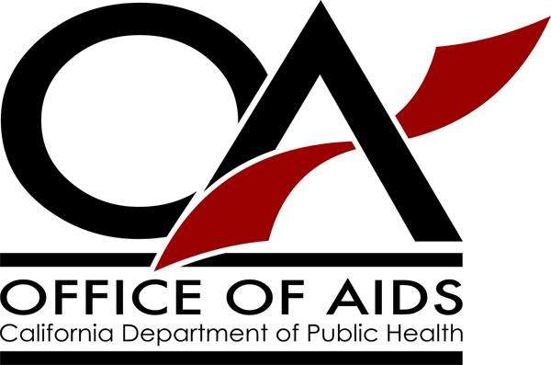
Non-Prescription Syringe Sale: Changes to California Law

As of January 1, 2015, licensed pharmacists have the discretion to sell hypodermic needles and syringes to adults age 18 and older without a prescription to reduce the spread of HIV, hepatitis C and other blood-borne diseases. There is no longer any limit on the number of needles and syringes that may be sold to a customer.
Adults age 18 and older may possess needles and syringes for personal use if acquired from a pharmacy, physician or authorized syringe exchange program. There is no longer any limit on the number of needles and syringes that an adult may purchase and possess.

These changes to California law were made by Assembly Bill 1743 (Ting, Chapter 331, Statutes of 2014). The relevant sections of California Business and Professions Code and Health and Safety Code now read:

California Business and Professions Code Section 4145.5(b):
Notwithstanding any other provision of law and until January 1, 2021, as a public health measure intended to prevent the transmission of HIV, viral hepatitis, and other bloodborne diseases among persons who use syringes and hypodermic needles, and to prevent subsequent infection of sexual partners, newborn children, or other persons, a physician or pharmacist may, without a prescription or a permit, furnish hypodermic needles and syringes for human use to a person 18 years of age or older, and a person 18 years of age or older may, without a prescription or license, obtain hypodermic needles and syringes solely for personal use from a physician or pharmacist.

California Health and Safety Code Section 11364:
(a) It is unlawful to possess an opium pipe or any device, contrivance, instrument, or paraphernalia used for unlawfully injecting or smoking (1) a controlled substance specified in subdivision (b), (c), or (e) or paragraph (1) of subdivision (f) of Section 11054, specified in paragraph (14), (15), or (20) of subdivision (d) of Section 11054, specified in subdivision (b) or (c) of Section 11055, or specified in paragraph (2) of subdivision (d) of Section 11055, or (2) a controlled substance that is a narcotic drug classified in Schedule III, IV, or V.
(b) This section shall not apply to hypodermic needles or syringes that have been containerized for safe disposal in a container that meets state and federal standards for disposal of sharps waste.
(c) Until January 1, 2021, as a public health measure intended to prevent the transmission of HIV, viral hepatitis, and other bloodborne diseases among persons who use syringes and hypodermic needles, and to prevent subsequent infection of sexual partners, newborn children, or other persons, this section shall not apply to the possession solely for personal use of hypodermic needles or syringes if acquired from a physician, pharmacist, hypodermic needle and syringe exchange program, or any other source that is authorized by law to provide sterile syringes or hypodermic needles without a prescription.

The California Department of Public Health, Office of AIDS has posted materials for syringe exchange programs, pharmacies and law enforcement at www.cdph.ca.gov/syringeaccess.

